Assignmnet-2
1. All Blank RowS are removed.
Column Header is updated. 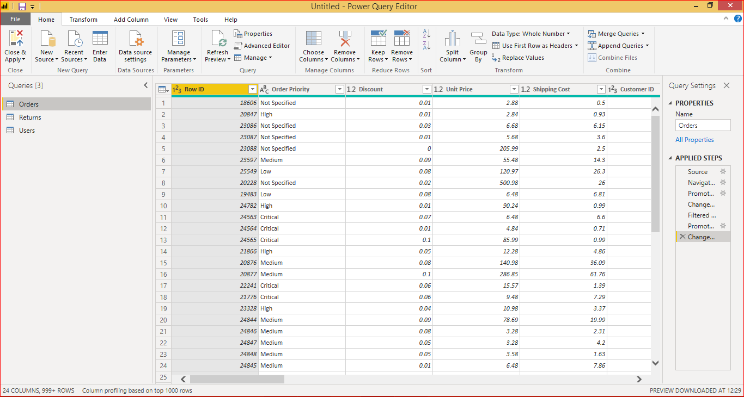

Creating text table with customer name ,Product Category and regions.
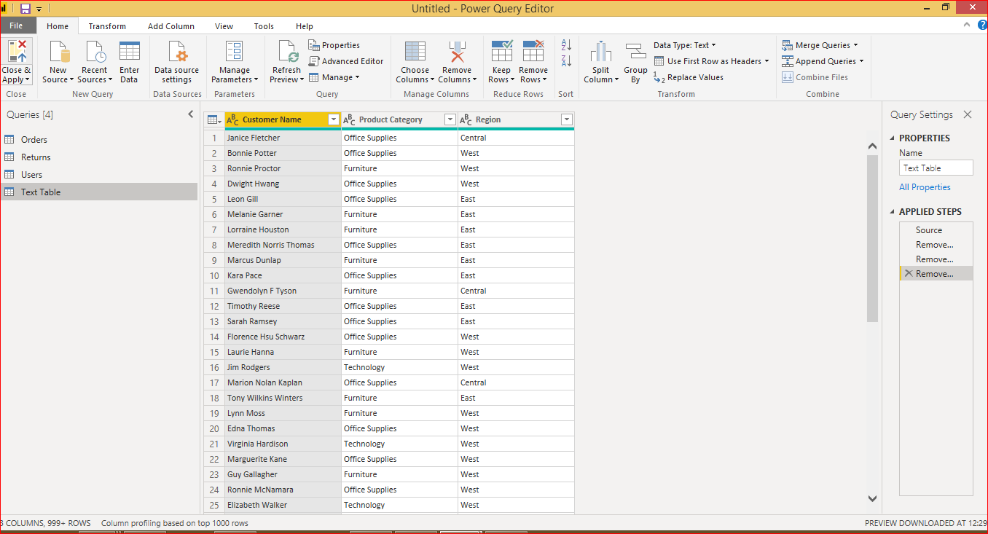
2. Line Chart and column clustered chart with state or provision, sales, discount.
California has the highest sales
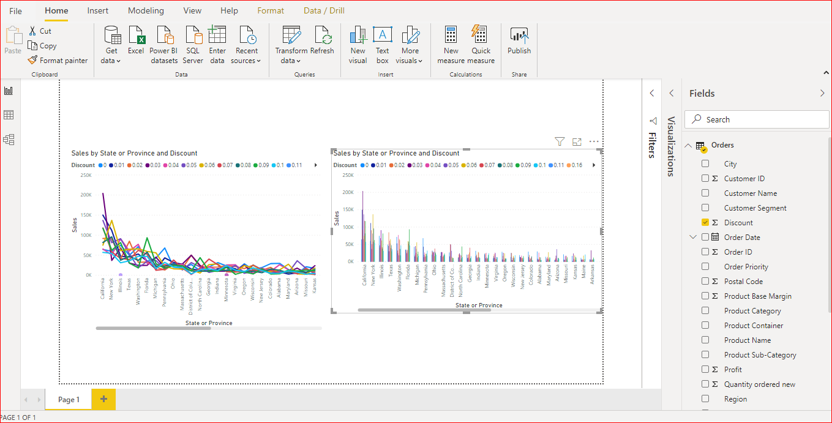
Donut and slicer: all the 3 charts were changing based on the slicer region selected
